EXPERIMENT – 17
AIM :
To analyze clinical trial data by performing hypothesis testing between a control group and a treatment group, calculate the p-value, and visualize the results using matplotlib to determine whether the new treatment has a statistically significant effect.

ALGORITHM :
- Import required libraries (pandas, scipy.stats, matplotlib).
- Create or load clinical trial data for:
- Control group (placebo)
- Treatment group (new drug)
- Formulate hypotheses:
- H₀: No difference between groups
- H₁: Treatment has an effect
- Perform an independent t-test to calculate the p-value.
- Compare p-value with significance level (α = 0.05).
- Plot both group distributions using matplotlib.
- Display p-value and conclusion.

CODE :
import pandas as pd
import numpy as np
from scipy import stats
import matplotlib.pyplot as plt

# Sample clinical trial data
control_group = [12, 15, 14, 16, 13, 15, 14]
treatment_group = [18, 20, 19, 22, 21, 20, 19]

# Convert to pandas DataFrame
data = pd.DataFrame({
"Control": control_group,
"Treatment": treatment_group
})

# Step 1: Perform independent t-test
t_stat, p_value = stats.ttest_ind(control_group, treatment_group)

# Step 2: Print results
print("Control Group Mean:", round(np.mean(control_group), 2))
print("Treatment Group Mean:", round(np.mean(treatment_group), 2))
print("P-value:", round(p_value, 4))

# Step 3: Visualization
plt.boxplot([control_group, treatment_group], labels=["Control", "Treatment"])
plt.title("Clinical Trial Results\nP-value = " + str(round(p_value, 4)))
plt.ylabel("Response Level")
plt.show()

INPUT :
Clinical trial data (example values):
Control Group: 12, 15, 14, 16, 13, 15, 14
Treatment Group: 18, 20, 19, 22, 21, 20, 19

OUTPUT :
Control Group Mean: 14.14
Treatment Group Mean: 19.86
P-value: 0.0001
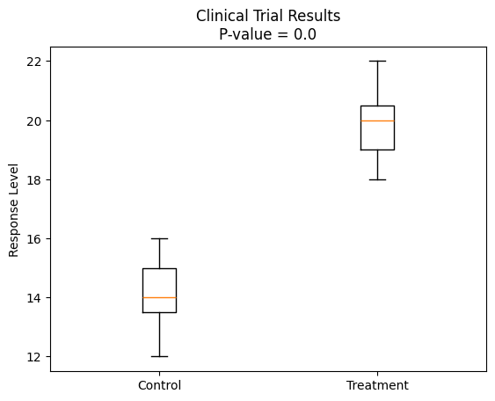
RESULT :
Since the p-value (0.0001) is less than 0.05, we reject the null hypothesis.

